Project 3: Multi-Container Flask Application with PostgreSQL Using Docker Compose.
Project Structure
Flask-Docker/
│── app.py Flask application
│── requirements.txt Python dependencies
│── Dockerfile Dockerfile for Flask app
│── docker-compose.yml Docker Compose configuration
└── README.md Project documentation

Step 1: Cloning the Repository.
Step 2: Build and Start the Containers.
Step 3: Using Default context.
Step 4: Creating a Default docker context.
Step 5: Creating a Git Clone
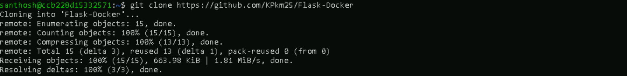
Step 6: Changing the directory to Flask-Docker.

Step 7: Build and Start the Containers.
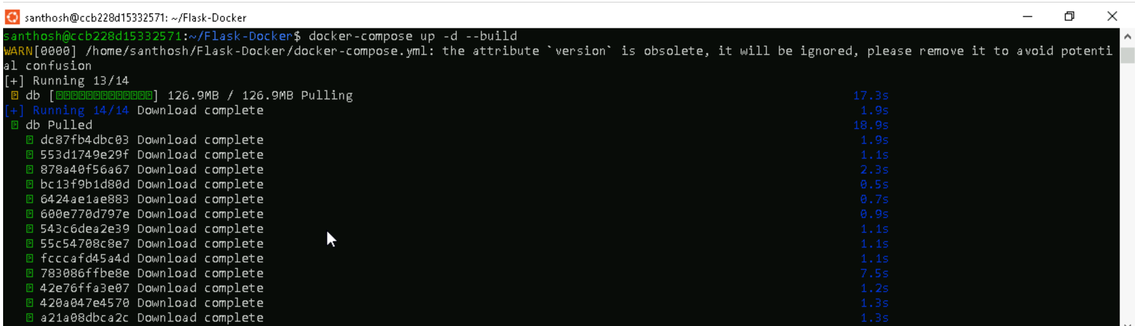
Step 8: Verify the Running Containers.
Step 9: Test the Application.
- `http://localhost:5000/` → Should return `"Flask App with PostgreSQL!"`
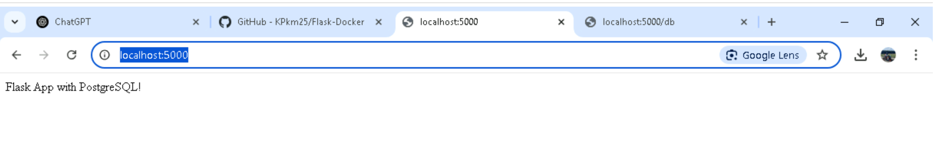
- `http://localhost:5000/db` → Should confirm database connection

Step 10: Stopping and Cleaning Up.
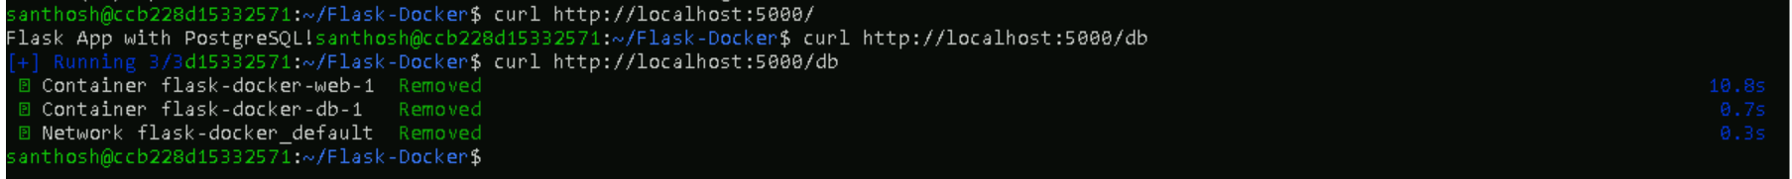

Step 11: To remove unused images and volumes.
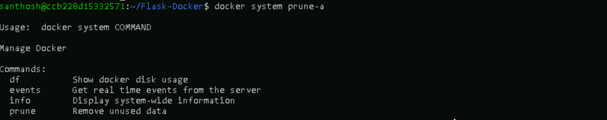
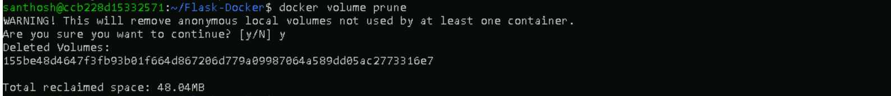
Step 12: Troubleshooting.
Stop the local PostgreSQL service:
Step 13: Change the PostgreSQL port in `docker-compose.yml` (e.g., `5433:5432` instead of `5432:5432`).
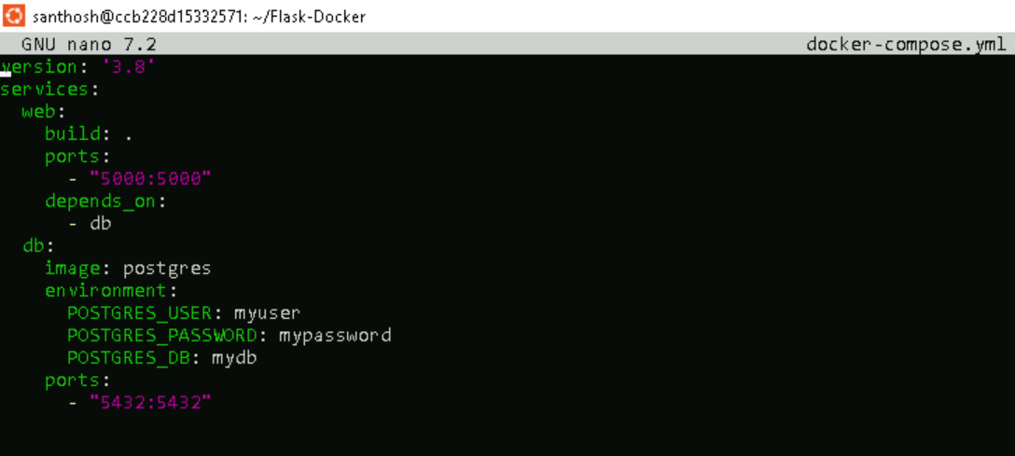

Step 14: Restarting Containers.
If something goes wrong with the application, try rebuilding the containers to reset everything:
